
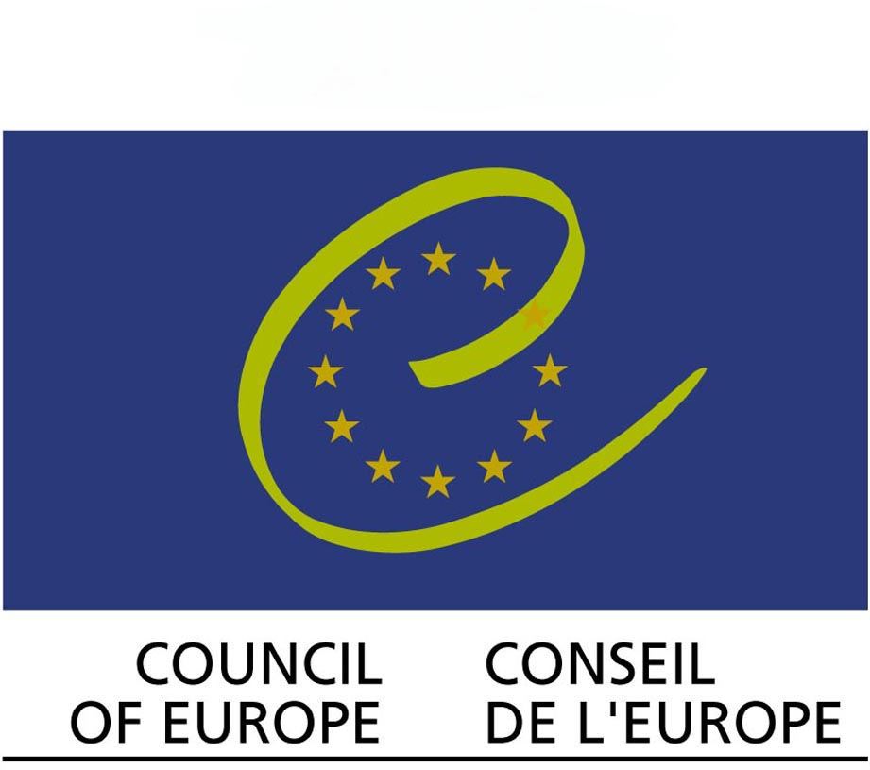

APPLICATION FORM
"FreeSbee - be free from stereotypes!"

23-29 May, 2011
Nizhny Novgorod, Russia

PLEASE FILL THIS FORM IN AND SEND TO
(avi@avimd.org)

Sending organization:
Name of the organization: AVI Moldova

Address: Moscova bd. 14, off.2
Post code: MD2068 | Country: Moldova
Tel.: 373 22325981 | Fax: 373 22325981
e-mail: avi@avimd.org | Website: www.avimd.org

Participant:
First name: |  |  |  | Last name:
Sex: | Date of birth: |  |  |  | Nationality:
Address: |  |  | Post code: |  |  | Country:
Tel: |  | Fax: |  | Mob: |  |  | e-mail:
What languages do you speak?

In case of emergency:
Name |  | Last name |  | Tel: |  |  | e-mail:

If you need visa:
Passport number:
Date and place of issue of your passport:
Expiry date:
Name of issuing authority:
Place of birth:
Previous visits in Russia (dates and reasons):
Applying for the visa (city in your country)
What is your occupation?
What cities in Russia do you plan to visit?

Estimation of your travel costs:
Expected dates of arrival and departure:
Arrival
Departure

We kindly ask you to answer the following questions, this information will help us to adopt the program to your needs.

- Your general motivation for participation in this training course:

- Please describe briefly your previous experience of leading events or projects. (any groups, workcamps or other international (national) projects)

- In which topics of the training course you are especially interested and why?

- What can be your own contribution to this training course?

THANK YOU☺!

Please return this form to avi@avimd.org till 05.05.2011

